Setting Priority When Designing a Network

An Assignment submitted in partial fulfillment of the requirements for the degree of
Bachelor of Science
in
Computer Science

CS 4404: Advanced Networking and Data Security
Term 3 - 2025
University of The People

February 6, 2024

Setting Priority When Designing a Network
The CIA triad is a framework that has been used to describe the three key pillars of cybersecurity, which include confidentiality, integrity, and availability. Osaro and Osazuwa (2023) define confidentiality in network security as an ethical and legal practice of protecting sensitive information from unauthorized persons. The duo also defines integrity in network security as ensuring information transmitted in the network remains unaltered. Finally, they define accessibility in network security as assuring easy access to information in the network by the authorized person only (Osaro & Osazuwa, 2023). These three terms have been used to develop the CIA triad framework as shown in Fig. 1 as a guide for formulating strategies that be applied in protecting sensitive information and ensuring it is well managed in the institutions.
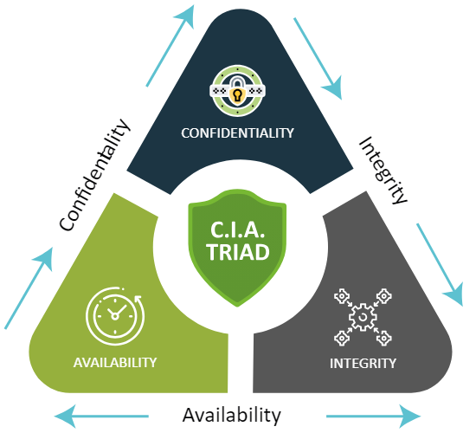
Fig. 1: CIA triad. Source: Website Security Store, 2022
An example of implementing confidentiality in a network is using Block Direct, which involves username and password verification on the login page. If the data entered is wrong or empty, the system provides a warning (Hidayasari et al., 2024). This helps ensure that only authorized users can access the system. An example of applying integrity in network security is using User and data filtering, which entails differentiating user access rights according to selected user levels such as a regular lecturer, a lecturer with a structural position, education staff, and a student if working in an educational institution (Hidayasari et al., 2024). This can be realized by using if statements in the code to check user credentials and assign appropriate access levels. Finally, an example of implementing availability in network security is using authentication, which involves checking if there is a database available to access the data. Users are required to enter a username and password before accessing the information they want to get (Hidayasari et al., 2024). If the credentials are registered, the user is directed to the appropriate menu and allowed to access the needed information.
The examples above have expounded how confidentiality, integrity, and availability can be applied in network security, which reveals that they are necessary. However, when designing my network security, I would give confidentiality the greatest consideration since it "ensures that information will be available only to authorized users and protects against unauthorized access." This is crucial for IoT devices, which often handle sensitive personal data. It is worth mentioning that the Internet of Things (IoT) devices are used in various domains including healthcare, home automation, and personal security. In these applications, protecting user privacy and preventing unauthorized access to sensitive information is paramount. Szymoniak and Kubanek (2024) report that there are over 2000 cyberattacks per day, highlighting the constant threat to data security. By considering confidentiality over integrity and availability, I will be able to address ethical concerns around data storage and the risk of data leakage from IoT systems. Therefore, I believe that focusing on confidentiality when designing my network will allow me to better protect users' private information and mitigate the potential harm from cyberattacks.

References
Hidayasari N., Kasmawi K., Mansur M., Husaini I., & Nuranisa P. (2024). Analysis of the application of CIA triad information security aspects in academic information systems. 12th Applied Business and Engineering Conference, 12, 562-567. https://abecindonesia.org/proceeding/index.php/abec/article/view/472
Osaro M., & Osazuwa C. (2023). Confidentiality, integrity, and availability in network systems: A review of related literature. International Journal of Innovative Science and Research Technology, 8(12), 1946-1955. https://ijisrt.com/assets/upload/files/IJISRT23DEC1449.pdf
Szymoniak, S., & Kubanek, M. (2024). Ethics in internet of things: Challenges and opportunities. In Smart Ethics in the Digital World: Proceedings of the ETHICOMP 2024. 21th International Conference on the Ethical and Social Impacts of ICT (pp. 225-228). Universidad de La Rioja.
Website Security Store. (2022, August 10). What is the CIA TRIAD & its importance for cybersecurity. https://websitesecuritystore.com/blog/what-is-the-cia-triad/

